PANDIT DEENDAYAL ENERGY UNIVERSITY
SCHOOL OF TECHNOLOGY


Course: Machine Learning
Project Report
B.Tech. (Computer Engineering)
Semester 7

Submitted To: |  | Submitted By:
Dr. Himanshu Gajera |  | Harshkumar Rana
 | 22BCP091
 |  | G3 - Batch

Contents
Experiment 1 : Detailed PV model 3
• Introduction to SAM Software: 3
• Key Features of SAM Software: 3
• Steps to Model a Renewable Energy System in SAM: 4
• PV System Design: 7
3.1. System Configuration: 7
3.2. Inverter Selection: 7
3.3. System Losses: 8
3.4. Tilt and Azimuth Angle: 8
3.5. System Configuration Summary: 8
• Financial Parameters: 9
4.1. Capital Costs: 9
4.2. Operating Costs: 9
4.3. Loan Financing: 9
• Results and Graphs Analysis: 10
5.1. Performance Analysis: 10
5.2. Financial Analysis: 10
• Comparison of Results for Ahmedabad and Hyderabad: 11
• Conclusions: 16
• References: 16
Experiment 2 : Solar Water Heating 17
• Steps to Model a Solar Water Heating System in SAM: 17
• Results and Graphs Analysis: 19
• Conclusions: 23
• References: 24

Experiment 1 : Detailed PV model

Introduction to SAM Software:

- The System Advisor Model (SAM) is a comprehensive software tool developed by the U.S. Department of Energy (DOE) for modelling renewable energy systems. SAM is widely used by engineers, researchers, and energy professionals to simulate and analyse the performance, financial feasibility, and environmental impacts of renewable energy projects. SAM allows users to model a variety of energy systems, including photovoltaic (PV) systems, concentrated solar power (CSP), wind turbines, geothermal systems, and biomass.
- SAM helps users make informed decisions about the design, installation, and operation of renewable energy systems by providing detailed performance predictions, economic analyses, and environmental impact assessments. The software has a user-friendly interface that allows users to configure system components, input location-specific weather data, and evaluate energy production and cost savings.

Key Features of SAM Software:

- System Performance Modelling: SAM allows users to model different renewable energy technologies such as solar PV, solar thermal, wind, and geothermal systems, with customizable inputs such as tilt angle, azimuth angle, module type, and inverter specifications.
- Financial Modelling: SAM provides a robust toolset for financial analysis, including lifetime cost, cash flow, payback period, return on investment (ROI), and net present value (NPV).
- Energy Output Predictions: SAM can simulate hourly, daily, monthly, and yearly energy generation based on location-specific weather data, system design, and operational settings.
- Sensitivity Analysis: SAM allows users to run sensitivity analyses to understand how changes in key parameters (e.g., system size, location, energy prices) affect system performance and costs.
- Environmental Impact Analysis: SAM estimates greenhouse gas emissions savings by comparing the renewable energy output to conventional fossil-fuel-based systems.

Steps to Model a Renewable Energy System in SAM:

Below are the general steps involved in modelling a renewable energy system using SAM software, focusing on a solar PV system as an example.
Step 1: Create a New Project
- Open SAM and start a new project by selecting the desired technology (e.g., Photovoltaic (PV)).
- Choose "Residential" or "Commercial" depending on your application type.
Step 2: Define Location and Weather Data
- Select Location: Choose the geographic location of your system (e.g., Ahmedabad, India). SAM provides access to a large weather database for various cities worldwide, or you can upload custom weather data.
- Location Information: Input the latitude, longitude, altitude, and time zone for your project location.
- SAM uses this location data to simulate solar radiation, ambient temperature, and weather conditions, which are critical for system performance.
Step 3: Configure System Components
- Modules:
  - Select the solar modules (e.g., monocrystalline or polycrystalline).
  - Input the module rating (e.g., 375 W) and module efficiency (e.g., 15%).
  - Adjust the temperature coefficient if necessary to account for temperature-related efficiency losses.
- Inverter:
  - Select an inverter from SAM’s available directory.
  - Specify the DC/AC ratio (e.g., 1.2) and ensure that the inverter’s capacity is appropriate for the system’s size.
  - SAM allows you to model MPPT (Maximum Power Point Tracking) settings to optimize energy conversion.
- System Configuration:
  - Set the number of modules per string and the number of strings for the system.
  - Define the total system size (e.g., 50 m² available for installation).
Step 4: Define Tilt and Azimuth Angles
- Set the tilt angle for the panels based on seasonal optimization (e.g., 15°-20° for summer in Ahmedabad).
- Set the azimuth angle based on the roof’s orientation (e.g., 270° for a west-facing roof).
- SAM will use these angles to calculate the optimal panel exposure to the sun for energy generation.
Step 5: Set Losses and Efficiency Parameters
- Soiling Losses: Input the soiling factor based on environmental conditions (e.g., 5% in a dusty environment).
- Temperature Losses: Enter the temperature coefficient and expected losses due to high temperatures.
- System Losses: Account for AC/DC losses such as wiring losses, inverter losses, and other electrical inefficiencies.
Step 6: Define Financial Parameters (if required)
- Cost Information: Enter the capital costs for the system components (e.g., modules, inverter, mounting structure).
- Incentives: If there are any available incentives or subsidies (e.g., government incentives), input them into SAM.
- Financial Analysis: Set up the operating costs, maintenance costs, and desired financial metrics such as payback period, return on investment (ROI), or net present value (NPV).
Step 7: Run the Simulation
- Run the simulation to calculate the system's energy generation, performance ratio, annual energy output, and financial performance.
- SAM will provide detailed reports showing hourly, daily, and annual energy production for the PV system based on the selected parameters.
Step 8: Analyze Results
- Performance Output: Review the annual energy production and monthly energy generation graphs.
- Financial Results: Analyze the payback period, ROI, and NPV based on your financial configuration.
- Sensitivity Analysis: If needed, run a sensitivity analysis to see how changes in system components, location, and environmental factors affect performance and economics.
Step 9: Create and Export Reports
- After running the simulation, you can generate detailed reports and export them in various formats (e.g., PDF, Excel).
- These reports typically include:
  - Energy Generation Graphs: Showing hourly, daily, or monthly energy output.
  - Financial Analysis: Summary of cost, savings, and payback period.
  - System Performance: Performance ratio, degradation over time, and other key performance indicators.

PV System Design:

3.1. System Configuration:
The residential photovoltaic (PV) system was designed for a roof area of 50 m² with the aim of generating sufficient electricity from solar energy. Given the available solar modules, the following key design parameters were applied:
- Module Specifications: The solar panel has a capacity of 375W per panel, with an efficiency of 15%.
- Available Area for PV Installation: The total available area for installing the PV system is 50 m².
- Number of Panels:
To calculate the number of panels that can fit into the available area, we first assume each panel occupies approximately 1.7 m². This leads to the following number of panels:
Number of panels= Available area/Area per panel​= 50/1.7 ​≈29 panels.
- DC Power Output: The total DC power output of the system is:
.Total DC Power=Number of panels×Panel capacity=29×375W=10,875W=10.875kW

3.2. Inverter Selection:
To convert the DC power generated by the panels into usable AC power, an inverter must be selected. The DC/AC ratio is to be maintained at 1.2, which allows us to size the inverter appropriately.
- Inverter Size Calculation: Inverter Size (AC Power)= Total DC Power /(DC/AC ratio) ​= 10.875/1.2 ​≈ 9.06 kW.
Based on this calculation, an inverter of 9.06 kW was selected from the available directory. This ensures that the inverter can handle the power produced by the system, accounting for losses and inefficiencies.

3.3. System Losses:
The following losses are taken into account in the system design:
- Soiling Losses: 4% per year (due to dust and dirt accumulation on the panels).
- AC Output Losses: 0.5% (due to inverter and electrical losses).
- Degradation Rate: 0.75% annually (reflects the gradual decrease in panel efficiency over time).

3.4. Tilt and Azimuth Angle:
Considering that the system is designed for the summer season, the tilt angle and azimuth angle were selected based on optimal solar exposure for the residential roof facing west:
- Tilt Angle: For maximizing energy production during summer, the tilt angle is set to 10°-20°.
- Azimuth Angle: Since the roof faces west, the azimuth angle is set to 270°.

3.5. System Configuration Summary:
- Module Capacity: 375W
- Total DC Power: 10.875 kW
- Inverter Size: 9.06 kW
- Tilt Angle: 15°-20° (Summer)
- Azimuth Angle: 270° (West-facing)
- Soiling Losses: 4%
- AC Output Losses: 0.5%
- Degradation Rate: 0.75%

Financial Parameters:

4.1. Capital Costs:
The financial parameters for the capital costs are provided below:
- DC Capital Cost: 1 $/W_dc
- AC Capital Cost: 0.75 $/W_ac
- Fixed Operating Cost: 30 $/kW/year, which escalates by 2% annually.

Capital Cost Calculation:
- DC Capital Cost = 1 $/W × 10.875 kW = 10,875 $
- AC Capital Cost = 0.75 $/W × 9.06 kW = 6,795 $
Thus, the total capital cost of the PV system is:
Total Capital Cost = DC Capital Cost + AC Capital Cost = 10,875 + 6,795 = 17,670 $.

4.2. Operating Costs:
The fixed operating cost per year is calculated as follows:
- Fixed Operating Cost for Year 1 = 30 $/kW × 9.06 kW = 271.8 $/year.
- The operating cost will increase by 2% every year for the next 25 years.

4.3. Loan Financing:
The installation of the PV system is financed through a loan with the following terms:
- Loan Amount: The full capital cost of 17,670 $.
- Loan Term: 25 years.
- Interest Rate: 12% per annum.

Loan Repayment Calculation:
Using the loan amortization formula, the monthly repayment can be determined. Over a 25-year period, the system will have monthly repayments based on the principal loan amount and the interest rate.

Results and Graphs Analysis:
After running the system through the SAM software for both Ahmedabad and Hyderabad, we obtained the following key results. These results have been presented as graphical outputs for better understanding.

5.1. Performance Analysis:
The performance of the PV system was analysed for both cities, including energy generation, performance ratios, and energy delivered to the load.
- Energy Generation vs Time: The graph shows the energy generated by the system throughout the year for both cities.
- Temperature Delivered by the System: The graph indicates how the system's temperature fluctuates across the days of the year.

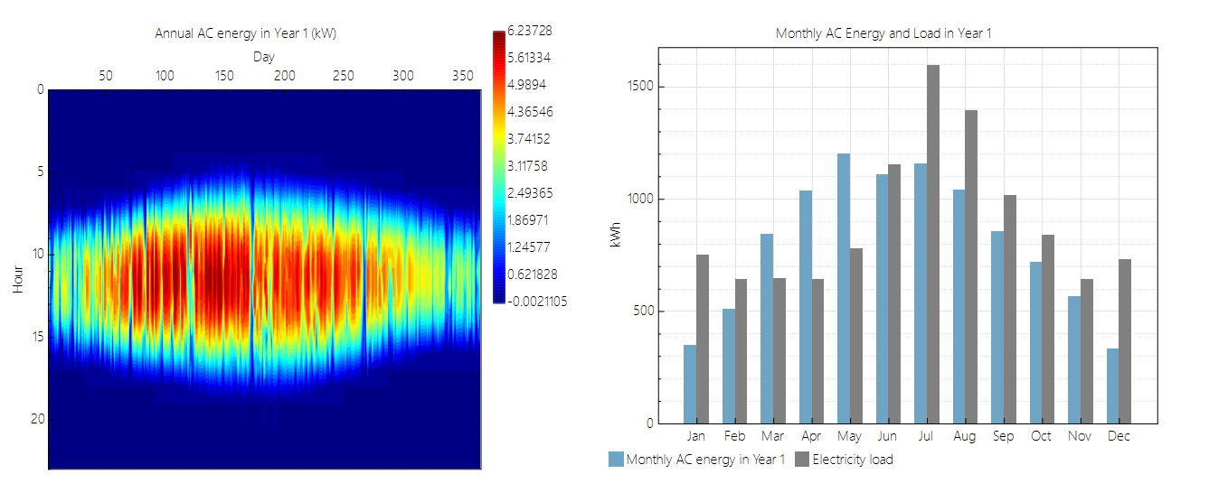
Figure 1 Performance graph

5.2. Financial Analysis:
The financial feasibility of the PV system was analysed using the capital cost, operating cost, loan repayments, and annual savings.
- Payback Period: The time required for the system to pay back its initial investment.
- Return on Investment (ROI): The profitability of the system over time.
- Net Present Value (NPV): The discounted value of the system’s future savings over 25 years.
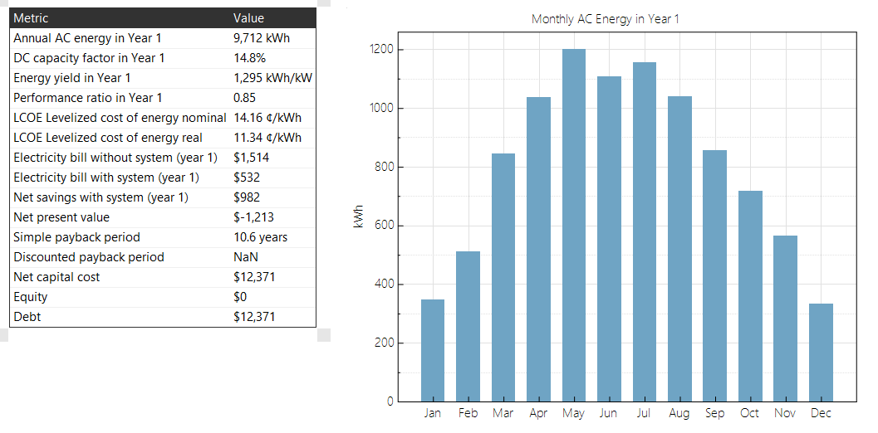
- Loan Repayment Schedule: Monthly and total loan repayment over the 25 years.
- Figure 2 Financial graph

Comparison of Results for Ahmedabad and Hyderabad:
Both the performance and financial results were compared for Ahmedabad and Hyderabad, considering their different solar irradiance and environmental conditions.
- Performance Metrics: The energy generated and system efficiency for both cities were compared.
- Financial Metrics: The payback period, ROI, and NPV for both cities were evaluated to determine the most financially viable location.

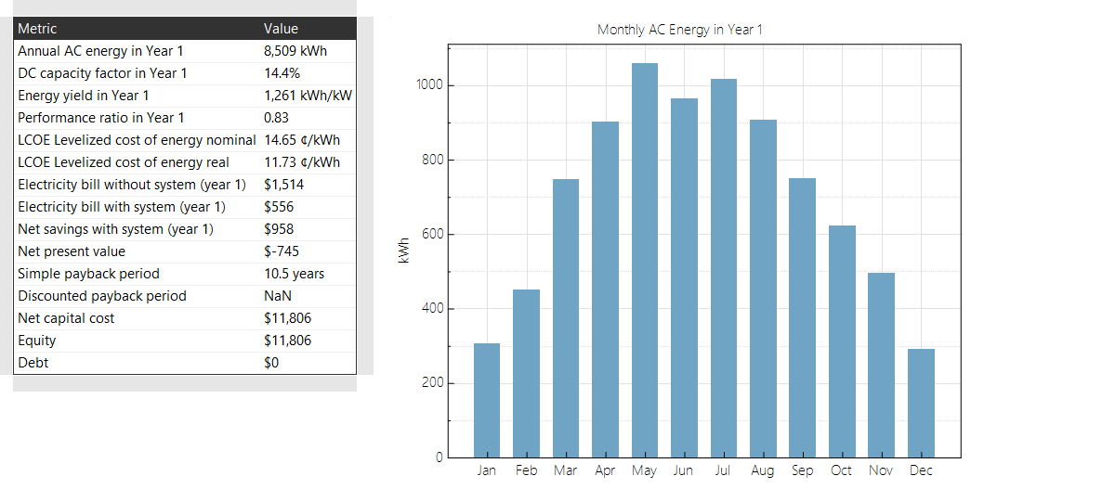
1.Hyderabad Main Data:

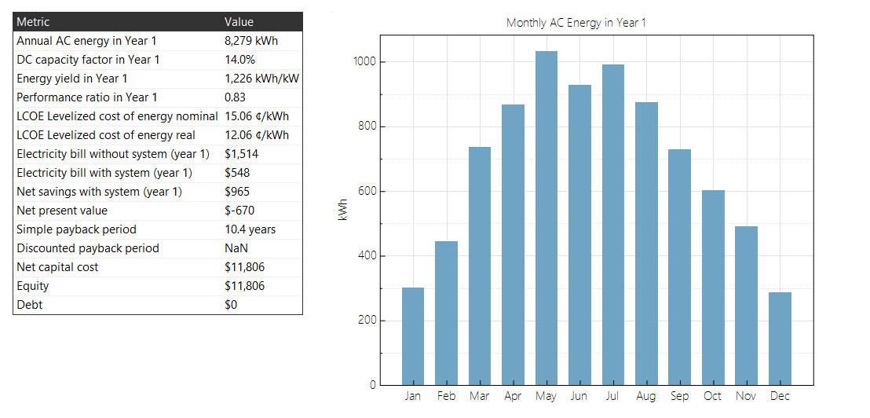
2.Ahmedabad Main Data:
Figure 3 Financial comparison graph

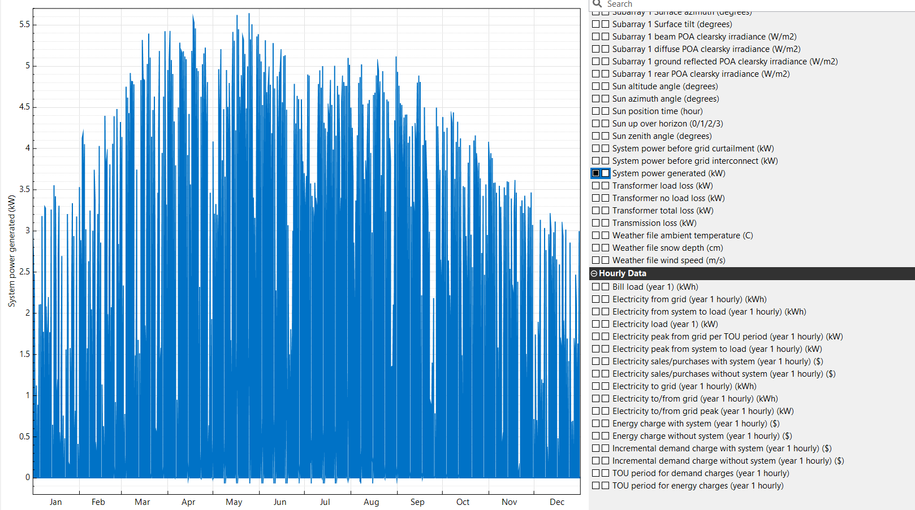
1.Hyderabad Power Generated Data:

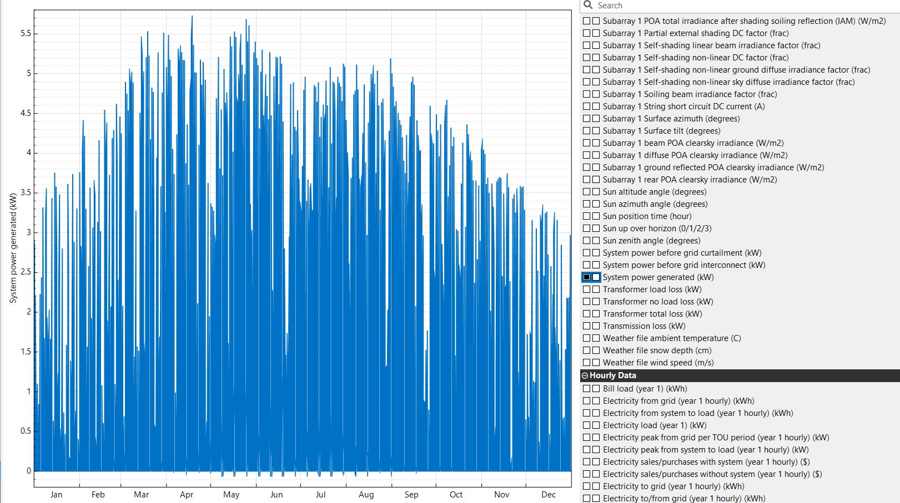
2.Ahmedabad Power Generated Data:
Figure 4 Power Generated graph

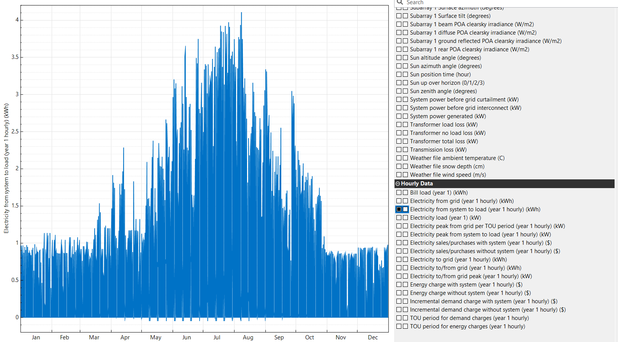
1.Hyderabad System to load Data:

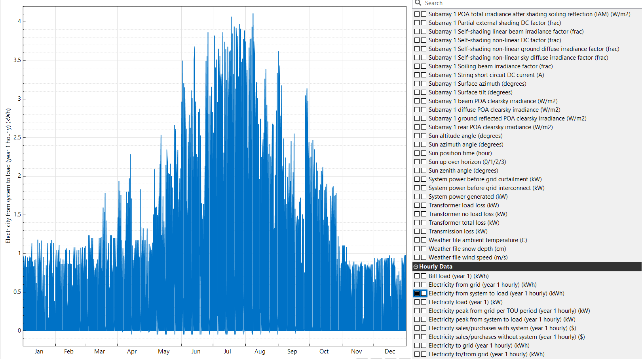
2.Ahmedabad System to load Data:
Figure 5 System to load transfer graph

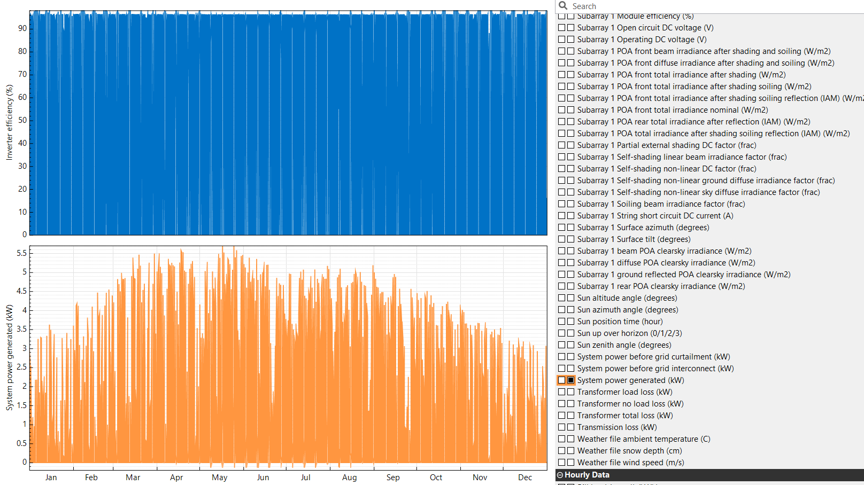
1.Hyderabad Inverter Efficiency and System power Generated Data:

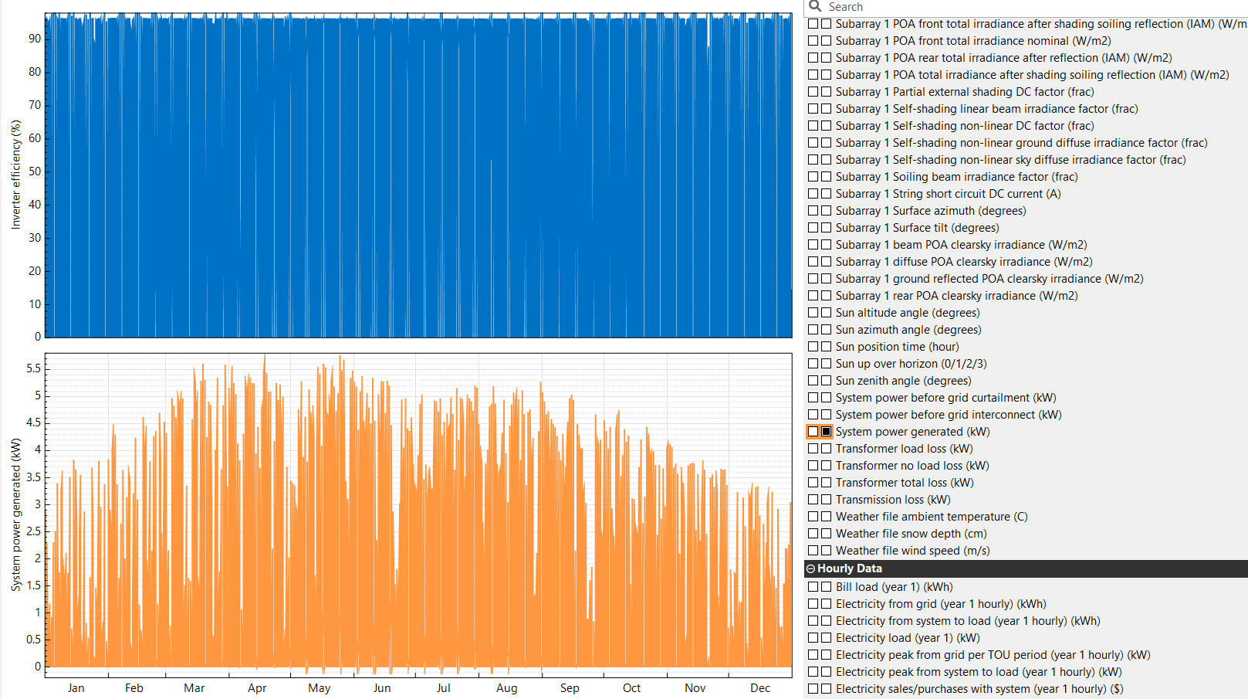
2.Ahmedabad Inverter Efficiency and System power Generated Data:
Figure 6 Inverter Efficiency graph and system power graph

Conclusions:
This report demonstrates the process of designing, simulating, and analyzing a residential Photovoltaic (PV) system. The financial modelling and performance simulation results provide valuable insights into the system's economic feasibility and long-term benefits. The analysis highlights the importance of correct system sizing, inverter selection, and financial planning in ensuring the success of solar energy projects.
This report provides a comprehensive overview of the design, financial analysis, and results for the residential PV system in Ahmedabad and Hyderabad. You can insert the graphs you generated during the simulation process into the relevant sections to complete your report.

References:
- U.S. Department of Energy (DOE) - SAM (System Advisor Model)
U.S. Department of Energy. (2023). System Advisor Model (SAM). Retrieved from:
https://sam.nrel.gov/
- Solar Energy Industries Association (SEIA)
Solar Energy Industries Association (SEIA). (2022). Photovoltaic (PV) Solar Panels: Technology & How They Work. Retrieved from:
https://www.seia.org/
- National Renewable Energy Laboratory (NREL) - Solar Radiation Data
NREL. (2021). Solar Resource Maps and Data Sets. Retrieved from:
https://www.nrel.gov/gis/solar.html
- EnergySage - Understanding Solar Panel Efficiency
EnergySage. (2023). Understanding Solar Panel Efficiency: What You Need to Know. Retrieved from:
https://www.energysage.com/
- International Renewable Energy Agency (IRENA)
International Renewable Energy Agency. (2022). Renewable Power Generation Costs in 2021. Retrieved from:
https://www.irena.org/

Experiment 2 : Solar Water Heating

Steps to Model a Solar Water Heating System in SAM:

Step 1: Open SAM and Select Solar Water Heating System
- Launch SAM and select “Create a new project.”
- Choose "Solar Water Heating" as the system type.
- Name your project (e.g., "Ahmedabad SWH System") and click "OK".

Step 2: Input Location and Resource
- Navigate to the "Location and Resource" tab.
- Search for Ahmedabad, India or upload a TMY (Typical Meteorological Year) file for the region.
- Ensure the solar irradiance and weather data for Ahmedabad are displayed correctly.

Step 3: Configure Collector Specifications
- Go to the "Solar Collector and Storage" tab.
- Input the collector specifications as follows:
  - Collector Area: 4 m².
  - Collector Thermal Capacitance: 17.7 kJ/°C.
  - Collector FₑR(Uₗ): 3 W/(m²·°C).
  - Collector FₑR(τ*α): 0.7.
  - Collector Slope: 30°.
  - Collector Azimuth: 0° (South-facing).
  - Incident Angle Modifier (IAM): 0.2.
  - Collector Flow Rate/Area: 0.015 kg/s-m².
  - Collector Fluid Specific Heat: 3.35 kJ/kg°C.

Step 4: Set Up Storage Tank Parameters
- In the same "Solar Collector and Storage" tab, configure the storage tank:
  - Tank Size: 300 liters.
  - Tank UA: 2.2 W/°C.
  - Tank Maximum Temperature: 100°C.
  - Tank Side Flow Rate/Area: 0.015 kg/s-m².

Step 5: Configure Piping and Insulation
- Still in the "Solar Collector and Storage" tab, input pipe and insulation properties:
  - Pipe Length (outdoors): 10 m.
  - Pipe Insulation Conductivity: 0.03 W/(m·°C).
  - Pipe Insulation Thickness: 0.02 m.
  - Ground Reflectance: 0.2.

Step 6: Configure Heat Exchanger and Draw Settings
- In the "Solar Collector and Storage" tab:
  - Heat Exchanger Effectiveness: 0.75.
  - Delta T On/Off: 10°C / 2°C.
  - Hot Water Draw Per Day: 200 liters.

Step 7: Simulation Settings
- Go to the "Simulation Control" tab.
- Set the simulation period to one year to analyze seasonal performance.
- Review the simulation time step (default is sufficient for most cases).

Step 8: Run the Simulation
- Click the "Simulate" button.
- Wait for the software to process the results.

Step 9: Analyze Results:
- After simulation, navigate to the Results tab to view key performance metrics:
- System Power Generated vs. Time (January 1–23): Daily power output over 23 days, reflecting consistent energy collection.
- Monthly Energy Delivered Over One Year: Total energy delivered each month, showing seasonal performance trends.
- Tank Temperature (°C) vs. Time (January 10–12): Variation in tank temperature over three days, with peaks during sunny hours.
- Temperature Delivered (°C) vs. Time (January 10–12): Hot water delivery temperature, highlighting efficient heat transfer during high solar energy periods.
- Export graphs and numerical data for inclusion in your report.

Results and Graphs Analysis:
The following graphs showcase the performance of the solar water heating system. These graphs help analyse energy production, system efficiency, and temperature variations for specific days and over a year.

1. System Power Generated vs. Time (January 1–23)
- Description: This graph represents the daily power output of the system during the period of January 1 to January 23.
- Key Observations:
  - Power output increases steadily during sunny hours, peaking around midday and declining towards the evening.
  - Fluctuations in power generation reflect variations in solar irradiance, weather conditions, and system performance.
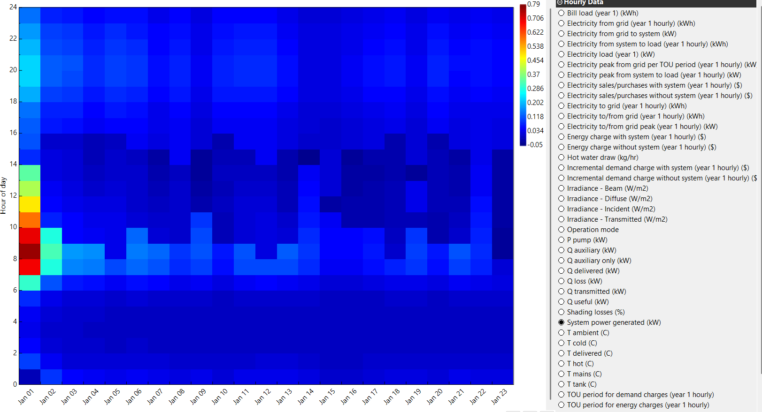
  - The graph confirms the system’s ability to consistently generate power during clear weather in winter.
Figure 7 System Power Generated graph

2. Monthly Energy Delivered Over One Year
- Description: This graph provides the total energy delivered by the system each month over a full year.
- Key Observations:
  - Higher energy delivery is observed during summer months (e.g., March to May), reflecting increased solar irradiance and longer daylight hours.
  - Energy output declines slightly during winter months due to reduced sunlight, but the system remains efficient.
  - This graph demonstrates seasonal performance trends and the system's suitability for year-round operation in Ahmedabad.
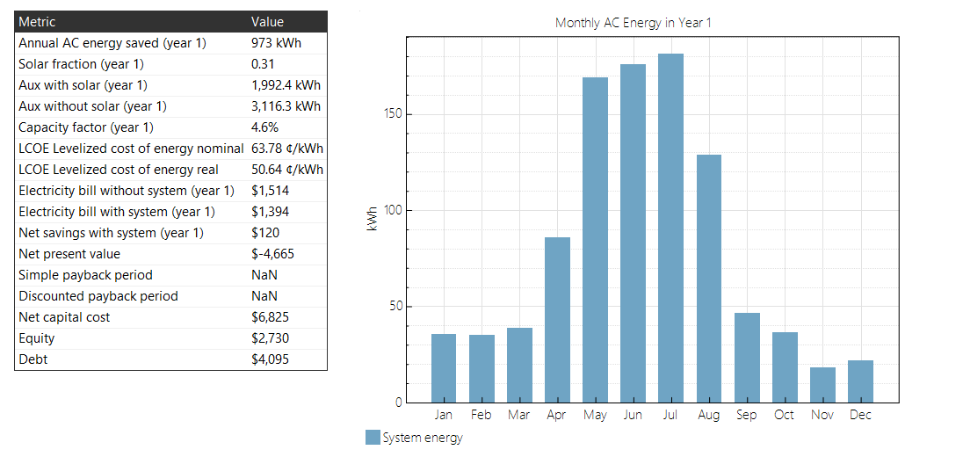
Figure 8 Financial Main graph and data

3. Tank Temperature (°C) vs. Time (January 10–12)
- Description: This graph shows the variation in the solar storage tank's temperature over three consecutive days in January.
- Key Observations:
  - Tank temperature increases during sunny hours as the system heats water and reaches peak values around midday.
  - At night, the temperature drops gradually due to thermal losses, though insulation helps retain heat.
  - The graph demonstrates the system’s ability to store and maintain thermal energy for extended periods.

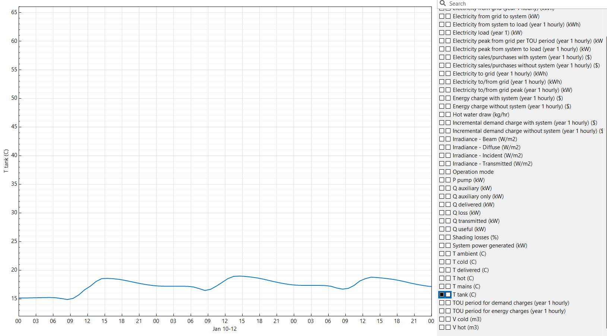
Figure 9 Tank temp vs time graph

4. Temperature Delivered (°C) vs. Time (January 01–22)
- Description: This graph illustrates the temperature of the hot water delivered by the system during the twenty two-day period.
- Key Observations:
  - Delivered water temperature closely matches the tank temperature during the day, reflecting efficient heat transfer.
  - Peak delivered temperatures occur during midday, ensuring hot water availability during high-demand hours.
  - The graph validates the system's capability to meet residential hot water requirements with minimal auxiliary heating.
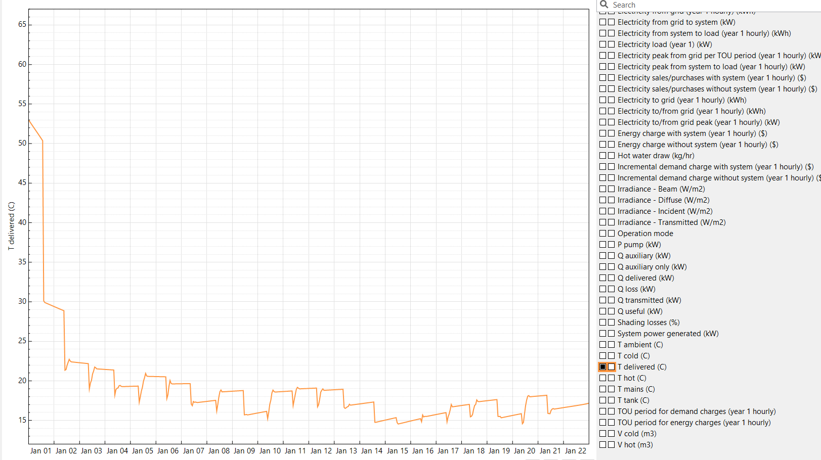
Figure 10 Temp delivered vs Time graph

Conclusions:
The solar water heating system simulation for Ahmedabad demonstrates its effectiveness in providing a reliable and sustainable source of hot water for residential use. The system operates efficiently during sunny hours, achieving high tank temperatures and delivering sufficient thermal energy to meet daily hot water demands. The following key insights were observed:
- Performance Highlights:
  - The system reaches peak tank temperatures during midday, aligning with maximum solar radiation availability in the summer.
  - Nighttime thermal losses are minimized due to well-insulated storage tanks, ensuring availability of hot water even after sunset.
  - The collector and storage tank parameters, including collector slope (30°), azimuth angle (0° for optimal solar gain), and flow rates, ensure high efficiency and optimal thermal energy transfer.
- Seasonal Trends:
  - Summer months exhibit higher thermal energy collection due to increased solar irradiance and longer daylight hours.
  - Winter months demonstrate consistent performance, though with reduced output due to lower solar radiation, highlighting the importance of optimizing system design for year-round performance.
- Environmental and Economic Benefits:
  - The system reduces dependency on conventional energy sources, leading to lower energy bills and a smaller carbon footprint.
  - The design, including insulation and flow rate optimization, ensures minimal energy losses, maximizing energy savings and thermal efficiency.
In conclusion, the solar water heating system is a cost-effective and environmentally friendly solution for residential applications in Ahmedabad. It ensures year-round availability of hot water, with peak performance in summer months, while minimizing energy losses and reliance on auxiliary heating.

References:
- SAM Software Documentation:
- National Renewable Energy Laboratory (NREL). "System Advisor Model (SAM) User Guide." Available at: https://sam.nrel.gov
- Solar Water Heating Principles:
- Kalogirou, S. A. (2004). Solar thermal collectors and applications. Progress in Energy and Combustion Science, 30(3), 231-295.
- Design and Simulation Standards:
- ASHRAE (2007). Handbook of HVAC Applications - Solar Energy Utilization. American Society of Heating, Refrigerating, and Air-Conditioning Engineers.
- Thermal Energy Storage Design:
- Sharma, A., et al. (2009). Review on thermal energy storage with phase change materials and applications. Renewable and Sustainable Energy Reviews, 13(2), 318-345.

